AI Powered Lead Generation

1. Introduction

1.1 Project Overview

The AI Powered Lead Generation System is an intelligent web-based application developed to automate and optimize the process of identifying, managing, and prioritizing potential business leads. In today's competitive business environment, organizations require efficient methods to attract and convert prospective customers while reducing the time and effort involved in manual lead management. This system utilizes Artificial Intelligence (AI) and Machine Learning (ML) techniques to analyse customer data, evaluate lead quality, and generate lead scores that help sales teams focus on the most promising prospects. By automating lead qualification, the system improves decision-making, increases operational efficiency, and enhances customer acquisition strategies.
The application consists of several integrated modules, including user authentication, lead management, AI-based lead scoring, dashboard visualization, report generation, and database management. Users can securely register and log into the system, add or manage lead information, and view AI-generated predictions regarding the probability of lead conversion. Administrators can monitor system activities, manage users, validate lead data, and generate analytical reports for business insights. The system stores all information in a centralized database, ensuring data consistency, security, and easy retrieval. With its scalable architecture and user-friendly interface, the AI Powered Lead Generation System provides a reliable solution for modern organizations seeking to improve sales performance and streamline their lead generation process while allowing future enhancements such as CRM integration, cloud deployment, and marketing automation.

1.2 Purpose
Purpose of the project :
- To automate the lead generation process using Artificial Intelligence.
- To improve the quality of leads through AI-based lead scoring.
- To reduce manual effort and human errors in lead management.
- To help sales teams identify and prioritize high-potential customers.
- To provide secure and centralized lead data management.
- To generate dashboards and reports for better decision-making.
- To increase sales efficiency and customer conversion rates. • To develop a scalable and user-friendly lead management system.

2. Ideation Phase

2.1 Problem Statement (Customer Problem Statement Template)

P.S.I  (Customer) | I’m trying to | But | Because | Which makes  me feel
Sales executive | Find potential, customer and increase sales | It takes too much time to identify quality leads | Lead generation is done manually and lacks intelligent filtering | Frustrated and less productive because I spent time on unqualified  leads
Marketing professionals | Generate and manage highquality leads | Many leads are duplicate or incomplete | There is no automated system to validate and score leads | Disappointed due to low campaign performance and poor conversion rates
Business owner | Improve customer acquisition and business growth | Sales team spend excessive time on low quality prospects | Traditional lead  management methods are inefficient | Concerned about missed opportunities and increased operational costs
Startup founder | Build a strong customer base quickly | Limited resources make manual lead generation difficult | There is no AI- based system to prioritise potential | Overwhelmed  by the effort required to find genuine leads
Sales manager | Monitor team performance and improve lead conversion | It is difficult to track and prioritise leads effectively | Customer existing systems do not provide predictive analytics or intelligent insights | Stressed because it affects sales targets and business growth

2.2 Empathy Map Canvas
Says | Thinks
I need more quality leads. | There must be a faster way to identify potential customers.
Manual lead management takes too much time. | AI can help to improve lead quality and save time.
I want to increase my sales conversion rate. | Accurate lead scoring will help me focus on the right prospects.

Does | Feels
Collects leads from multiple sources. | Frustrated by duplicate and low-quality leads.
Verifies customer information manually. | Stressed due to low conversion rates.
Follows up with potential customers. | Motivated when quality leads generate successful sales.

2.3 Brainstorming
Brainstorming ideas for AI powered lead generation system
Idea number | Idea | Benefits
1 | AI-based Lead Scoring | Prioritizes high-quality leads and improves conversion rates.
2 | Automated Lead Validation | Removes duplicate and invalid lead records automatically.
3 | Centralized Lead  Management | Stores all lead information in one secure platform.
4 | Interactive Dashboard | Provides real-time insights and lead analytics.
5 | Predictive Analytics | Predicts the probability of lead conversion using Machine Learning.
6 | Role-Based User Access | Ensures secure access for administrators and users.
7 | Report Generation | Generates PDF and Excel reports for business analysis.
8 | Future CRM Integration | Enables seamless integration with CRM platforms like Salesforce and HubSpot.

3 Requirement Analysis Phase
3.1 Customer Journey Map Journey stages:
Awareness - Customer learns about the Al Lead Generation System.
Registration - Customer creates an account and logs in.
Lead Entry - Customer enters or uploads lead details.
Lead Analysis - Al analysis and scores the leads.
Lead Management - Customer views, updates, and manages leads.
Dashboard & Reports - Customer monitors analytics and generates reports.
Decision Making - Customer prioritizes high-quality leads for follow-up.

3.2 Solution Requirements Functional Requirements:
Requirement ID | Functional requirement
FR-1 | User registration
FR-2 | User login
FR-3 | Add leads
FR-4 | Edit/Delete leads
FR-5 | AI lead scoring
FR-6 | Search & Filter leads
FR-7 | View dashboard
FR-8 | Generate reports
FR-9 | Manage users(Admin)
FR-10 | Secure logout

Non-Functional Requirements:
Requirement ID | Non-Functional requirement
NFR-1 | High performance
NFR-2 | Data security
NFR-3 | User-friendly interface
NFR-4 | High reliability
NFR-5 | System scalability
NFR-6 | Fast response time
NFR-7 | Easy maintainability
NFR-8 | Data accuracy
NFR-9 | Availability
NFR-10 | Compatibility across browsers

3.3 Data Flow Diagram
Users → Salesforce UI → Custom objects → Validation rules → Flows → Reports → Dashboards.
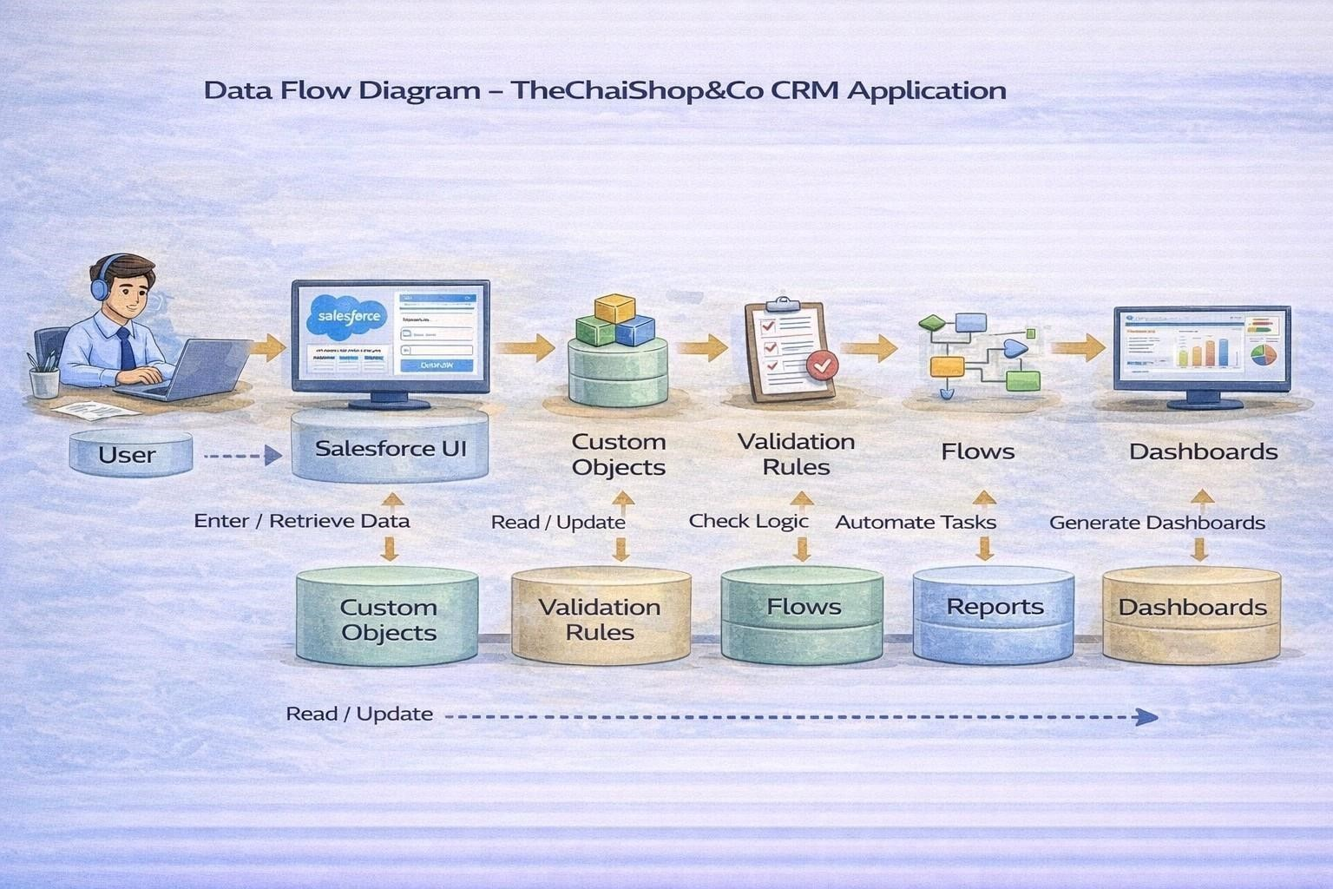

3.4 Technology Stack
Layer | Technology used | purpose
Frontend | HTML, css, bootstrap, Javascript | User interface
Backend | Python , flask | Application logic
Database | SQLite/ MySQL | Data storage
Machine learning | Scikit-learn , pandas, numpy | Lead scoring & prediction
Development tool | VS Code | Code development
Version control | Git, GitHub | Source code management
Operating system | Windows 10/11 | Development environment
Web browser | Google chrome / Microsoft Edge | Running the application

4 Project Design Phase

4.1 System Architecture
The Ai Powered lead generation system follows a three-tier architecture consisting of the presentation layer , Application layer , and database layer. The presentation layer provides a userfriendly interface through which users can register , log-in , add leads , and view reports. The application layer , developed using python and flask , processes user requests , perform lead validation and interacts with the AI model to generate lead scores. The Database layers stores user information , lead details and prediction results securely. This architecture ensures efficient communication between different modules while maintaining scalability , security , and reliability.

4.2 System Design
The system is designed to automate the complete lead management process. Users can securely register and log in, add or upload lead information, and manage lead records. The AI module analyzes lead data using machine learning algorithms and assigns a lead score based on conversion probability. The generated results are stored in the database and displayed through dashboards and reports, helping organizations make informed business decisions.

4.3 Modules of the system
Module | Description
User authentication | Registration , login and logout
Lead management | Add, edit, delete, and view leads
AI lead scoring | Predicts lead quality using Machine Learning
Dashboard | Displays lead statistics and analytics
Reports | Generates PDF/ excel reports
Database management | Stores users and lead information securely

4.4 Input Design

The input design focuses on collecting accurate and valid information from users. Input forms include user registration details and lead information such as company name, contact person, email, phone number, industry, and lead source. Validation techniques are implemented to minimize errors and prevent duplicate records.

4.5 Output Design

The system provides outputs in the form of AI-generated lead scores, lead status, dashboard analytics, graphical reports, and downloadable reports in PDF or Excel format. These outputs enable users to analyze lead quality and make data-driven decisions efficiently.

4.6 Database Design
The database consists of tables for Users, Leads, and AI Predictions. It maintains relationships using primary and foreign keys to ensure data integrity. The database stores user credentials, lead details, prediction scores, and report information securely for efficient retrieval and management.

5 Project Planning & Scheduling

5.1 Project Flow
The AI Powered Lead Generation System project was planned by dividing the development process into multiple phases to ensure systematic execution and timely completion. The project began with identifying the problem and gathering user requirements, followed by analyzing the feasibility and defining the project objectives. During the design phase, the system architecture, database structure, user interface, and AI workflow were prepared. The implementation phase involved developing the frontend using HTML, CSS, Bootstrap, and JavaScript, while the backend was developed using Python and Flask. Machine Learning algorithms were integrated to perform AI-based lead scoring and prediction. After development, the system underwent testing to verify functionality, performance, and security. Finally, the application was deployed, and the project documentation was completed.

5.2 Project planning & scheduling
Phase | Activity | Duration
Phase 1 | Problem identification & requirement gathering | 1 Week
Phase 2 | System analysis & planning | 1 Week
Phase 3 | System design | 1 Week
Phase 4 | Frontend & backend development | 2 Weeks
Phase 5 | AI model development & integration | 1 Week
Phase 6 | Testing & bug fixing | 1 Week
Phase 7 | Deployment & documentation | 1 Week

6. Project Development Phase

6.1 Project Flow
The AI Powered Lead Generation System follows a simple workflow to automate lead management. Users first register and log into the system. They then enter or upload lead details, which are validated for accuracy. The validated data is analysed by the AI model to generate a lead score and predict conversion potential. The results are stored in the database and displayed on the dashboard. Finally, users can manage leads, view reports, and make informed business decisions.
Project Flow :
Start → login/Register → add lead details → validate data → AI lead scoring → store in database → view dashboard & reports → logout → End.

6.2 What you’ll learn
- AI and Machine Learning basics.
- Python and Flask web development.
- Database management (SQLite/MySQL).
- AI-based lead scoring and prediction.
- Frontend development using HTML, CSS, Bootstrap, and JavaScript.
- Dashboard and report generation.
- User authentication and data security. • End-to-end project development and deployment.

7. Implementation

7.1 Salesforce Account
Salesforce is your customer success platform, designed to help you sell, service, market, analyze, and connect with your customers. Salesforce has everything you need to run your business from anywhere. Using standard products and features, you can manage relationships with prospects and customers, collaborate and engage with employees and partners, and store your data securely in the cloud. So what does that really mean? Well, before Salesforce, your contacts, emails, follow-up tasks, and prospective deals might have been organized something like this: https://youtu.be/r9EX3lGde5k Creating Developer Account Creating a developer org in salesforce.
- Go to https://developer.salesforce.com/signup
- On the sign up form, enter the following details :
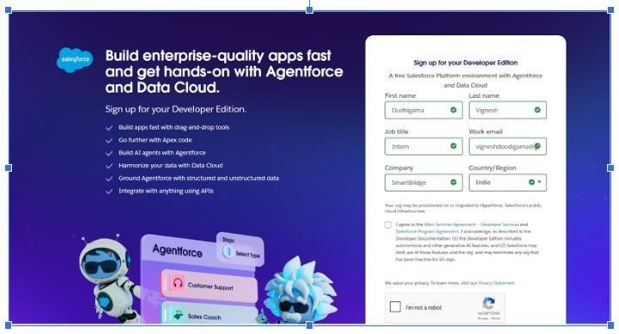

- First name & Last name
- Email
- Role : Developer
- Company: College Name
- County : India
- Postal Code : pin code

Username : should be a combination of your name and company
This need not be an actual email id, you can give anything in the format : username@organization.com
Click on sign me up after filling these.

Account Activation
  - Go to the inbox of the email that you used while signing up. Click on the verify account to activate your account. The email may take 5-10mins.
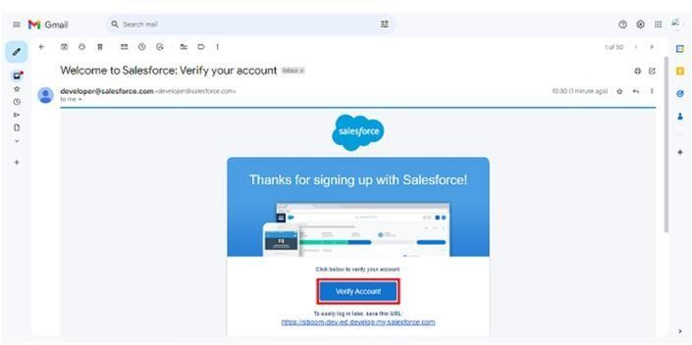

  - Click on Verify Account
  - Give a password and answer a security question

7.2 Object Creation
- Access Salesforce Setup
Log in to your Salesforce org.
Click the ⚙️ Gear Icon in the upper-right corner.
Select Setup from the dropdown menu.
You will be redirected to the Salesforce Setup Home.
- Navigate to Object Manager
In the Setup menu, click Object Manager at the top navigation bar.
This will display a list of all standard and custom objects in the org.
- Create a New Custom Object
Click Create → Custom Object (or click New Custom Object if visible).
The Custom Object Definition page will open.
- Configure Custom Object Details
Fill in the following required fields:
Basic Information
  - Label: The display name of the object (e.g., Project).
  - Plural Label: (e.g., Projects).
  - Object Name: Auto-filled based on the Label.
  - Record Name:
o Choose Text or Auto-Number. o If Auto-Number, define the format (e.g., PROJ-{0000}).
Optional Features (Enable Based on Use Case)
  - Allow Reports
  - Allow Activities
  - Track Field History
  - Allow Search
  - Allow Notes & Attachments
  - Enable Streaming API
  - Enable Enhanced Email 5. Set Object-Level Security
Choose whether you want to:
  - Add Notes & Attachments
  - Allow Sharing
  - Enable Reports and Activities
  - Allow Bulk API Access
(These settings ensure users can interact with the object as intended.) 6. Save the Custom Object
Click Save.
The object is now created and you will be taken to its detail page.

7.3 Tabs
Tabs in Salesforce are navigation elements that allow users to access specific objects, functionalities, or custom pages directly from the application interface. They act as entry points that lead users to records, list views, Visualforce pages, Lightning components, or external content. Tabs help organize the workspace and make frequently used objects or tools easily accessible. Salesforce supports various types of tabs, including Custom Object Tabs, Web Tabs, Visualforce Tabs, and Lightning Page Tabs, each serving a different purpose in enhancing user navigation and experience.
- Access Salesforce Setup o login to Salesforce .
  - click the ⚙️ Gear icon in the top-right corner .
  - select setup to open the setup homepage .

- Navigate to the Tabs section

In the left-hand search bar, type Tabs.
Under User Interface, click on Tabs.
This page lists all available Standard Tabs, Custom Object Tabs, Visualforce Tabs, Lightning Page Tabs, and Web Tabs.
- Create a New Custom Object Tab
Locate the section labeled Custom Object Tabs.
Click New.
The Custom Object Tab creation page will open.
- Configure Tab Settings
Step A: Select the Custom Object
  - Choose the custom object you want to create a tab for (e.g., Project, Invoice, Application).
Step B: Choose a Tab Style
  - Select a Tab Style (icon + color) from the available options.
  - You can also create a custom tab icon if needed.
Step C: Enter Additional Information (Optional)
  - Add a description for internal reference.
  - Choose a custom splash page (rarely used).
- Set Tab Visibility for Profiles
After selecting style and object, you will see tab visibility settings for each profile:
Choose one of:
• Default On – visible in app navigation by default • Default Off – hidden but users can add it manually • Tab Hidden – completely hidden from profile .
Set based on user access requirements.
- Add the Tab to Custom Apps (Optional but Recommended)
After setting visibility, Salesforce will prompt you to assign the tab to Apps. Select the apps where you want this tab to appear.
Click Save to complete the configuration.
- Verify the Tab
After saving:
Go to the Salesforce App (e.g., Sales, Service, a custom Lightning App).
Click the App Launcher (9 dots icon).
Search for your custom object/tab.
Confirm that it displays correctly and users can create/view records.

7.4 Fields & Relationships Custom field creation:
Field label | API Name | Data type
Lead score | Lead_Score_c | Number
Lead category | Lead_category_c | Picklist (hot, warm, cold)
Product interest | Product_interest_c | Picklist(training , consulting , certification)
AI summary | AI_Summary_c | Long text area

Steps : Creating the “AI summary ” custom field
- Go to Setup
Login to salesforce .
Click the ⚙️ gear icon →setup.
- Open Object manager
In Setup, click Object Manager (top navigation).
Search for and select the object you want to add the field to (Example: Lead, Custom Object, etc.).
- Go to Fields & Relationships
In the left sidebar of the object, click Fields & Relationships.
Click the New button.
- Choose Field Type Select Long Text Area. Click Next.
- Enter Field Details
Fill in the field information:
Field Label: AI Summary
API Name: AI_Summary c (auto-filled)
Length: Set max length (e.g., 32,768 characters)
Visible Lines: Choose the number of display lines (e.g., 5–10) Click Next.
- Set Field-Level Security
Select which profiles should have visibility or edit access.
Click Next.
- Add to Page Layouts
Select the page layouts where the field should appear. Click Save.

7.5 Application Creation
A Salesforce application is a collection of tabs, objects, and tools grouped together to help users complete specific business processes. It provides a dedicated workspace where users can access all related data—such as accounts, contacts, opportunities, dashboards, or custom objects—without searching across the system. Applications can also be customized with logos, colors, and layouts to match an organization's branding while improving user experience and efficiency.
To create an application in salesforce :
Setup → App Manager → New Lightning App → Enter App Details → Choose Branding → Add Navigation Items → Add Utility Items (optional) → Assign to Profiles → Save & Finish. These steps guide you from opening the setup area to defining the app name, selecting tabs (objects), adding tools, choosing who can use the app, and finally making it available in the App Launcher for users.

7.6 Validation Rules
Activity 1 : To create a validation rule to lead object Click on validation rules → click on new.
Enter the rule name as Reject_Personal_Email.
Check active .
Insert the Error Conditional Formula as :
OR{
CONTAINS (Email,”@gmail.”),
CONTAINS(Email, “@yahoo.”),
CONTAINS(Email,”@hotmail.”),
CONTAINS(Email,”@outlook.”)
}
- Enter the Error Message as:
“Personal email domains like Gmail, Yahoo, Hotmail, and Outlook are not allowed.”
- Select the Error Location as Email.
- Click Save.
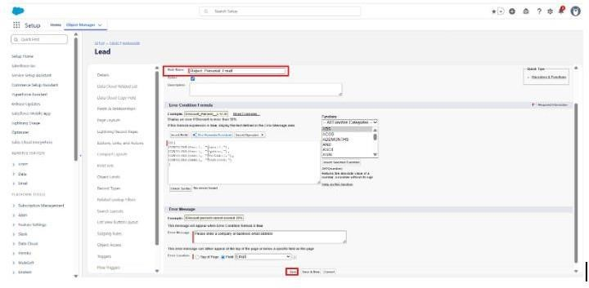

7.7 Flows
Steps to create the Record-Triggered Flow
- From Setup, in the Quick Find box, search for Flows.
- Click New Flow.
- Select Category: Triggered.
- Select Type: Record-Triggered Flow.
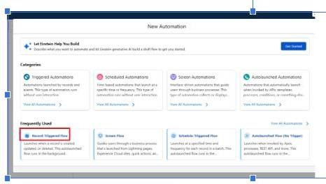

  - Configure the Start Element:
  - Object: Lead
Trigger: A record is created or updated
    - Entry Condition Requirements: (example based on common lead email use cases— adjust to match your flow)
    - Optimize the Flow For: Actions and Related Records
    - When to Run the Flow: Run Immediately
- Click Done.
- Add the Email Action
Add the Send Email Action
  - Click the + icon below the Start element.
  - Select Action.
  - In the Action search bar, type: Send Email
  - Select: Send Email
  - Configure the action fields: • Label: Send Lead Email
    - Subject: (enter your email subject)
    - Body: {{!$Record.Name}}
{!$Record.AI_Summary c}
Recipient Addresses: (enter email formula or field reference; e.g., {!$Record.Email})

Sender Type: Org-Wide Email or Default Is HTML Body: True
RecordId → {!$Record.Id} (if included in your setup)
Click Done and Activate.

7.8 Agent force

Create prompt template.

- Click the Gear icon → select setup.
- In the Quick find box , search the Einstein in setup.
- Click the Einstein setup.
- Enable turn on Einstein .

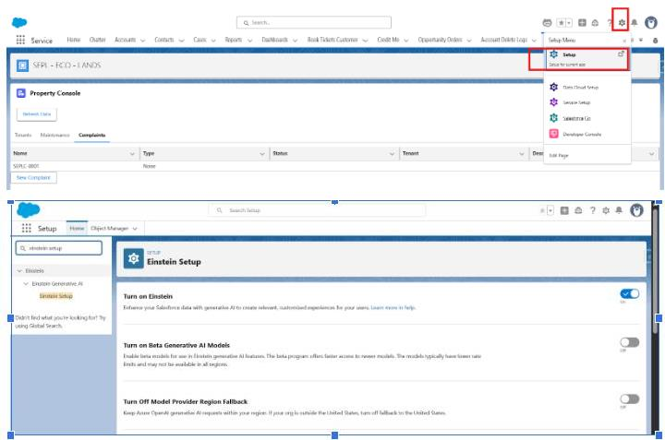

Refresh the page after enabling Einstein .
Prerequisite : Create AI_summary_cField
Before selecting the field in prompt Builder , you must create the AI summary custom field in the lead standard object .

Steps:

- Click Gear Icon → Setup.
- In Quick Find, search Object Manager.
- Select Lead
- Click Fields & Relationships → New.
- Select Long Text Area → Click Next.
- Field Label: AI Summary
API Name auto-populates as AI_Summary_c

- Set Length = 32000 and Visible Lines = 5–10.
- Click Next → Save.

Step 2: Open Prompt Builder
- In the Quick Find box, search Prompt Builder.
- Click Prompt Builder.
- Click new prompt template.

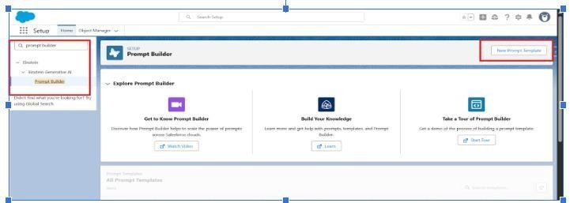

Step 3 : Select prompt type

1. Choose Field Generation .
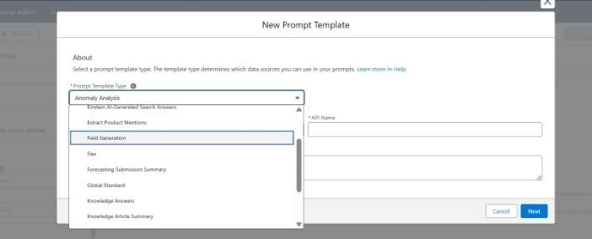

- label_Name: AISummary Field Generation Field
- API Name auto-populates.
- Object_Lead.
4.Field : AI Summary
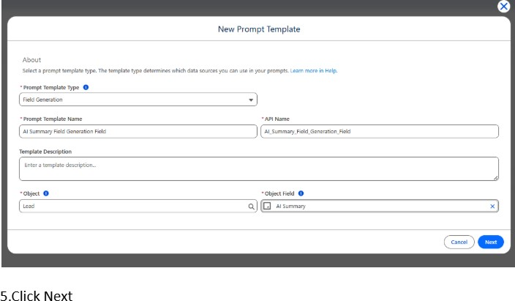

Step 5 : Insert Resources
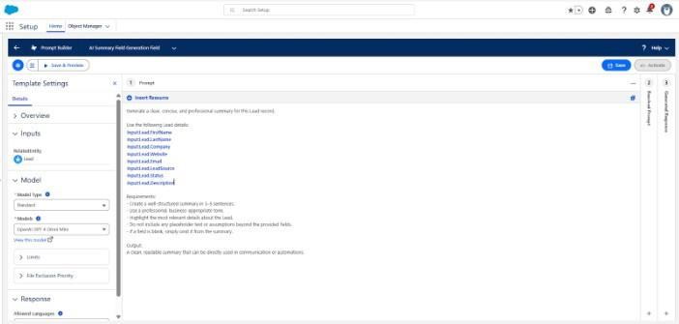

- Full Name: {!Lead.Name}
- Company: {!Lead.Company}
- Email: {!Lead.Email}
- Phone: {!Lead.Phone}
- Lead Source: {!Lead.LeadSource}
- Lead Status: {!Lead.Status} • Description: {!Lead.Description}

Step 6: Enter Sample Prompt
Write the below prompt:
Generate a detailed summary of this Lead using the selected fields.
Explain the Lead’s background, company information, contact details, status, source, and any key notes clearly.
Summarize relevant details such as the current engagement stage, potential interest level, communication history, and any important remarks.
Provide the summary in a clean, structured, and easy-to-understand format.

Step 7: Save and Activate
- Click Save.
- Click Activate.
Your Prompt Template is now ready.

Activity 2 : Deploy Prompt Builder in Visa Application Object Using Lightning App Builder. Step 1:
Open Any Record
- Click the App Launcher (9 dots).
- Search for Lead Object
- Open any existing Student Record.

Step 2: Edit Lightning Page
1. Click the Gear icon → Select Edit Page.
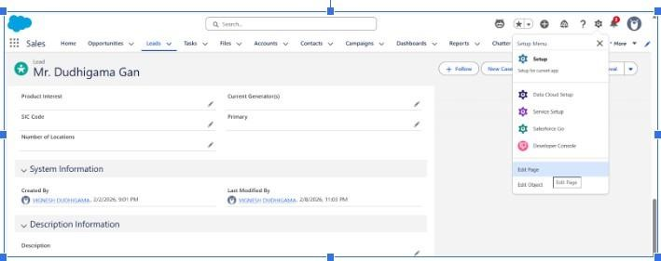

Step 3 : Upgrade to Dynamic Detail Page
1.Click on the detail page.
2.Click upgrade now.

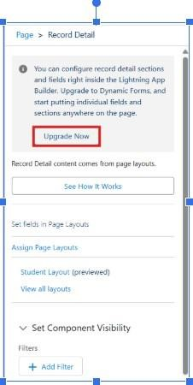

- Click Next.
- Select the Lead Object Layout.
- Click Finish.

Step 4: Assign the Prompt Template to the Field .
Click the AI_Summary_c field on the layout.

- In the right-side panel, search Prompt Template.
- Select your template: AI Summary Field Generation Field
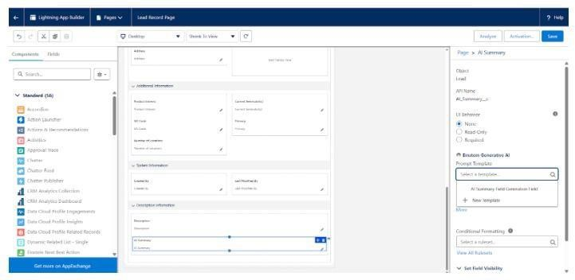
Step 5: Save & Activate the Page
- Click Save.
- Click Activate.
- Select Assign as Org Default.
- Choose Desktop and Phone.
- Click Next.
- Click Save.
- Click Back.

Activity 3 : Testing to Lead object Record
- For the AI Summary field, click the icon in the last corner. That is the AI icon we created using Prompt Builder.
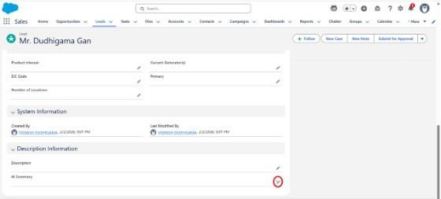

- Click stars icon on AI Summary Field
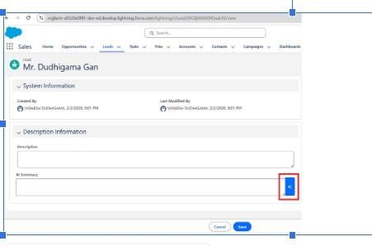
- Click Use.
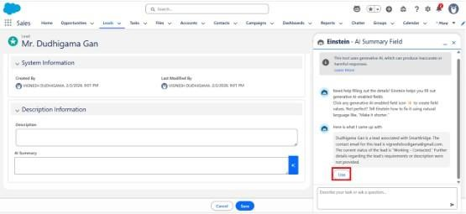

- Click Save.
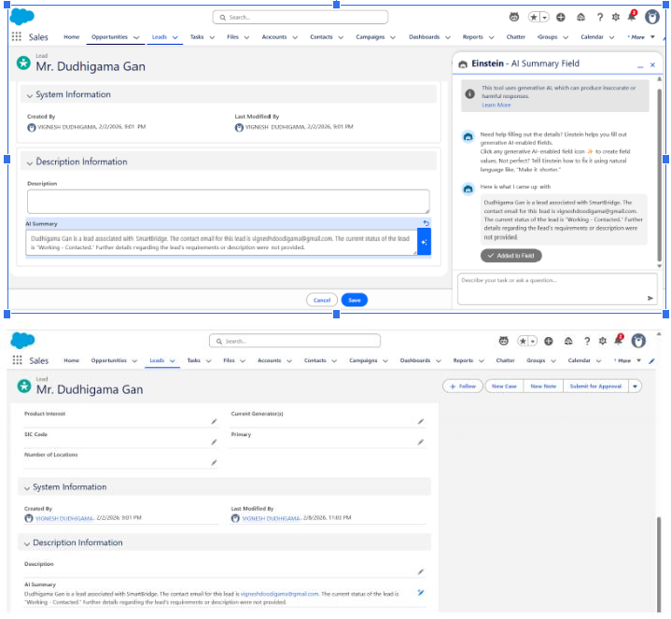

7.9 Profiles
- Access Salesforce Setup
Log in to Salesforce.
Click the ⚙️ Gear Icon in the top-right corner. Select Setup to open the Setup Home.
- Navigate to Profiles
In the left-hand Quick Find search box, type Profiles.
Under Users, click Profiles.
A list of all available profiles (Standard and Custom) will be displayed.
- Select the Profile to Modify
From the profile list, click the Profile Name you want to configure (e.g., System Administrator, Standard User, Custom Sales Profile).
This opens the Profile Detail page.
- Configure Profile Permissions
On the Profile Detail page, you can configure:
  - Object Permissions
Click Object Settings
    - Select the object (e.g., Lead, Custom Object)
    - Set Read, Create, Edit, Delete, View All, Modify All
  - Field-Level Security
    - Click Field Permissions or go to an object → View Field-Level Security
    - Control field visibility and edit access
  - Tab Settings
Scroll to Tab Settings
    - Set each tab to Default On, Default Off, or Tab Hidden
  - App & System Permissions
    - Scroll to Administrative Permissions
    - Scroll to General User Permissions
  - Record Type Assignments
    - Click Record Type Settings (if available)
    - Assign or remove record types
- Save Profile Changes
After completing the required updates, scroll down.
Click Save to apply the changes.
- (Optional) Clone Profile to Create a Custom Profile From the Profiles list, click Clone next to an existing profile.
Give the new profile a name.
Configure permissions as needed.
Save.

7.10 Users
Users — Navigation Steps 1. Access Salesforce Setup
Log in to Salesforce.
Click the ⚙️ Gear Icon in the top-right corner.
Select Setup to open the Setup Home page.

2. Navigate to Users
In the left-hand Quick Find search box, type Users.
Under the Users section, click Users.
A list of all active, inactive, and frozen users will be displayed.

- Create a New User
At the top of the Users list, click New User.
Fill in the required information:
  - First Name o Last Name o Alias o Email o Username o Nickname
  - Role (optional) o User License o Profile
Scroll down and click Save.

- Edit an Existing User
In the Users list, click Edit next to the user you want to update.
Make the necessary changes
(profile, role, email, active status, time zone, etc.). Click Save.

- Activate, Deactivate, or Freeze a User
- Deactivate a User Click Edit beside the user.
Uncheck Active.
Click Save.
- Freeze a User (Temporary Lock)
Click the Freeze button next to the user’s name.
(This prevents login without deactivating the user.)
- Reset a User Password
On the Users list, click the Reset Password button beside the user.
Salesforce sends the user a password reset link via email.

- Assign Permission Sets (Optional)
Open the user record by clicking the User Name.
Scroll to Permission Set Assignments.
Click Edit Assignments.
Add or remove permission sets.
Click Save.

7.11 Roles
- Access Salesforce Setup
Log in to Salesforce.
Click the ⚙️ Gear Icon in the top-right corner.
Select Setup to open the Setup Home.

- Navigate to Roles
In the Quick Find search bar (left panel), type Roles.
Under Users, click Roles.
The Role Hierarchy page will open, showing existing roles in a tree structure.

- Create a New Role
On the Role Hierarchy page, click Add Role.
Choose a parent role (if applicable) to determine visibility and hierarchy.
Enter role details:
  - Role Name o Role Label
  - This role reports to: (set parent role) o Optional: Add a Description
Click Save.

- Edit an Existing Role
On the Role Hierarchy page, find the role you want to modify.
Click the Edit link beside the role name.
Update the role name, parent hierarchy, or description.
Click Save.

- Assign Users to a Role
In the Role Hierarchy, click the role name.
On the role details page, scroll to the Users in This Role section.
Click Add.
Select one or more users from the list.
Click Save.

8. Advantages & Disadvantages

8.1 Advantages
- Automates the lead generation process.
- Reduces manual effort and human errors.
- Improves lead quality using AI-based scoring.
- Helps prioritize high-potential customers.
- Saves time and increases sales productivity.
- Provides secure and centralized lead management.
- Generates dashboards and analytical reports. • Scalable and easy to maintain.

8.2 Disadvantages

- Requires high-quality data for accurate predictions.
- AI model needs periodic training and updates.
- Initial setup and implementation can be time-consuming.
- Performance depends on the accuracy of the machine learning model.
- Requires technical knowledge for maintenance.
- Internet connection may be needed for cloud-based deployment.
- May incur additional costs for future integrations and upgrades

9. Conclusion
The AI Powered Lead Generation System is an intelligent and efficient solution that automates the process of lead generation and management using Artificial Intelligence and Machine Learning. It helps businesses identify, analyze, and prioritize high-quality leads, reducing manual effort and improving sales productivity. The system provides secure lead management, AI-based lead scoring,
and real-time dashboards to support better decision-making. Overall, the project enhances customer acquisition, increases conversion rates, and offers a scalable platform that can be extended with future technologies such as CRM integration, cloud deployment, and advanced analytics.

10. Future Scope
- Integrate with CRM platforms (Salesforce, HubSpot).
- Deploy the system on cloud platforms (AWS, Azure).
- Develop Android and iOS mobile applications.
- Enhance lead prediction using Deep Learning models.
- Integrate email and marketing automation tools.
- Add AI chatbot support for lead collection.
- Implement real-time analytics and dashboards.
- Support multiple languages for global users.
- Enable social media lead generation.
- Provide AI-based recommendations and insights.

11. Appendix
Abbreviations
- AI – Artificial Intelligence
- ML – Machine Learning
- UI – User Interface
- DB – Database
- API – Application Programming Interface
- HTML – HyperText Markup Language
- CSS – Cascading Style Sheets
- JS – JavaScript
- SQL – Structured Query Language
- IDE – Integrated Development Environment
- Tools and Software Used
- Python
- Flask
- HTML
- CSS
- Bootstrap
- JavaScript
- SQLite / MySQL
- Scikit-learn
- Pandas
- NumPy
- Visual Studio Code
- Git & GitHub
- Python Official Documentation
- Flask Documentation
- Scikit-learn Documentation
- Pandas Documentation
- NumPy Documentation
- HTML5 & CSS3 Documentation
- Bootstrap Documentation
- SQLite/MySQL Documentation
- Lead: A potential customer interested in a product or service.
- Lead Scoring: Ranking leads based on their likelihood of becoming customers.
- Machine Learning: A branch of AI that enables systems to learn from data and make predictions.
- Dashboard: A visual interface that displays lead statistics and reports.
- Prediction: Estimating the probability of lead conversion using AI models.
- This appendix provides supporting information, terminology, tools, and references used in the development of the AI Powered Lead Generation System.

